Workshop: ICP for Data – Analyze

Lab 3 – Commit Model and Create Online Deployment

*May 29, 2018*

*Author: Rui Fan* [*rui.fan@ibm.com*](mailto:rui.fan@ibm.com)

*Reference assets from: Sidney Phoon* [*yfphoon@us.ibm.com*](mailto:yfphoon@us.ibm.com)

**Table of contents**

Contents

**7. Deployment: Commit and push project**

**8. Model Management & Deployment**

8.1 Create a Project release

8.2 In the Assets tab, create an online and batch deployment for the deployed Telco_Churn_ML_model

8.3 Launch the project and enable

8.4 Click the online deployment created in step 8.2, and test the model in the API interface.

# **7: Commit and Push Project to Model Management & Deployment**

1. Go back to the project homepage, you will see the message that ask if you want to **commit and push** the changes to this project from the model development enviornment. This will push all of the assets to the Model Management & Deployment (MMD) environment Click ‘**Commit and Push**’.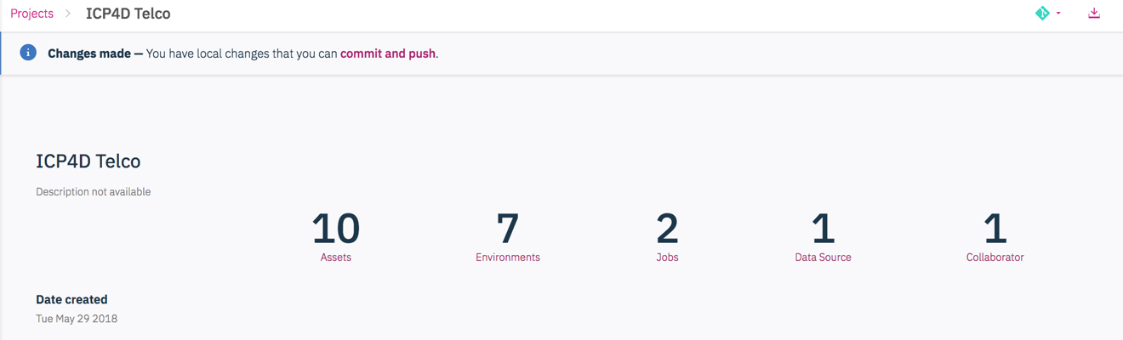
2. Then you will see there is a list of the assets that are created in this project. Because this is the first time creating this project type in the following commitment message: ‘**Initial build and save of a telco churn model**’. Under the version tag enter: ‘**Initial’** .

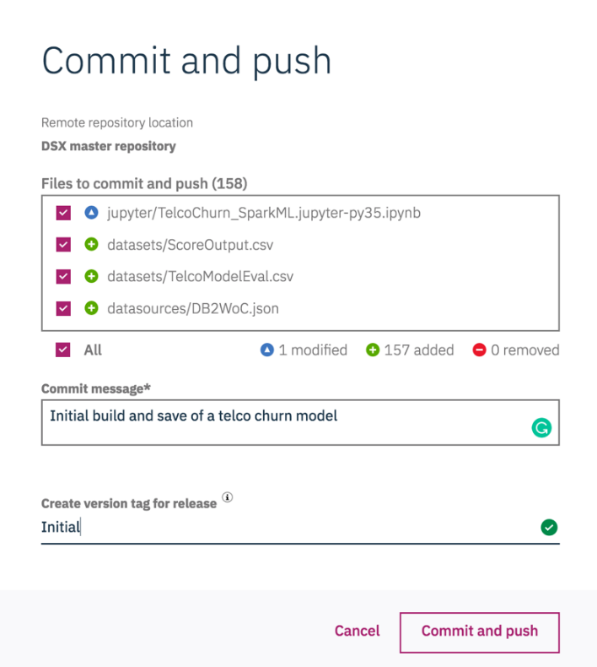

1. Click ‘**Commit and push**’

**Note:** We are now moving out of the Model Development environemnt where we manage data, build notebooks and test models to the the Model Management & Deployment environment where we will use all of those assets to create **automated** **processes**.

# **8: Model Management & Deployment (MMD)**

**Creating a Project release within MMD**

1. Navigate back to the home menu and select ‘**Analyze’** and then ‘**Model management & deployment’**.

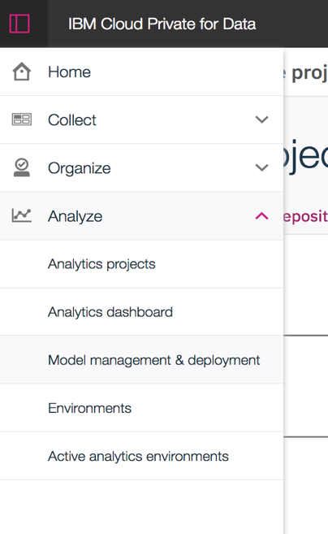

1. Add a project release by selcting ‘**+ project release’.**
2. Add in the details of your Project Release under the ‘**From DSX’** tab:
   * Under Name type on something you could easily track such as **‘ICP4DTelcoChurn’**
   * Under ‘Route’ enter something like ‘**telco-churn’** .This is a unique part of the url that will be assigned to all of the assets that are created related with this project. All should be lowercase.
   * Select the source project and tag that created in the previouse step.
   * Click ‘**Create’**

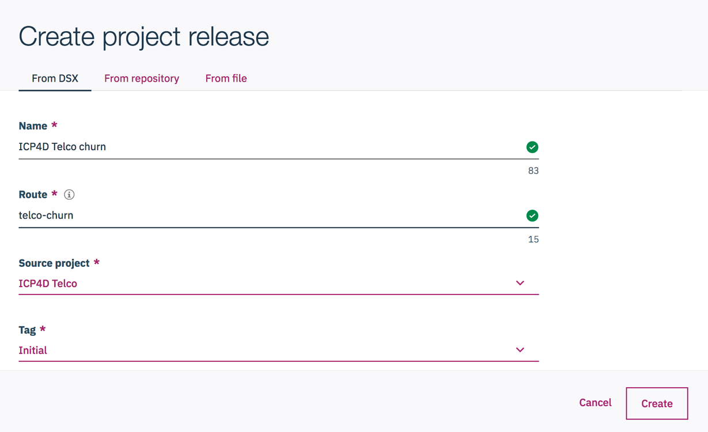

**Now we will Create an online deployment for Telco_Churn_ML_model**

1. In the **assets** tab, you can see all of the analytics assets. There are notebooks, models, and scripts that we created for batch scoring .
2. Selct the ‘TelcoChurn_SparkML_model’ on the left and add service by clicking the **‘+web service’** button on the top right. This will add a oneline deployment service for this model

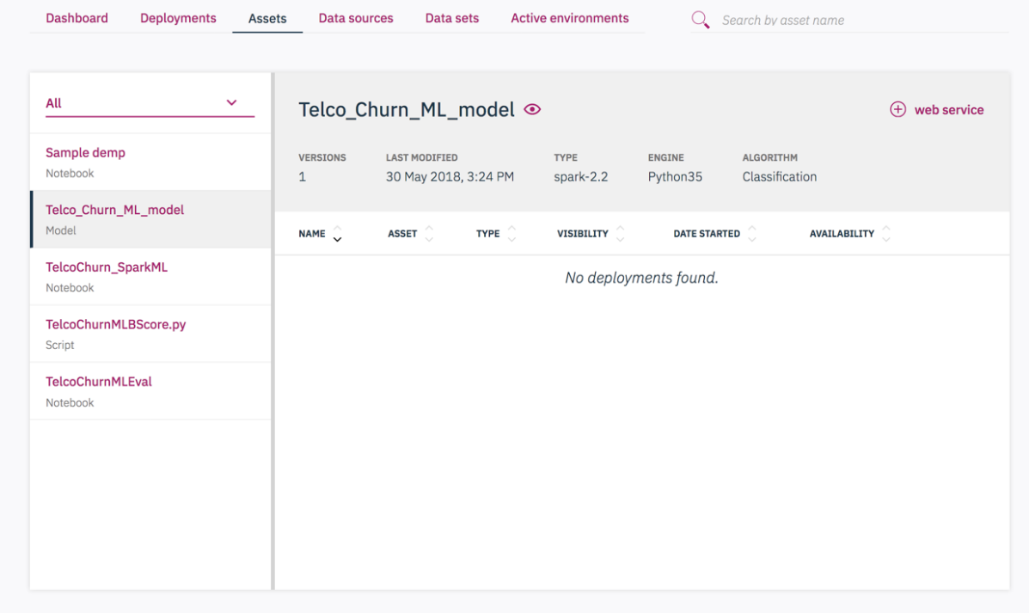

1. Enter in a name you will remember like ‘telcochurnonlinescore’ . You can leave the other values set to their defaults.
2. Click on **‘Create’**

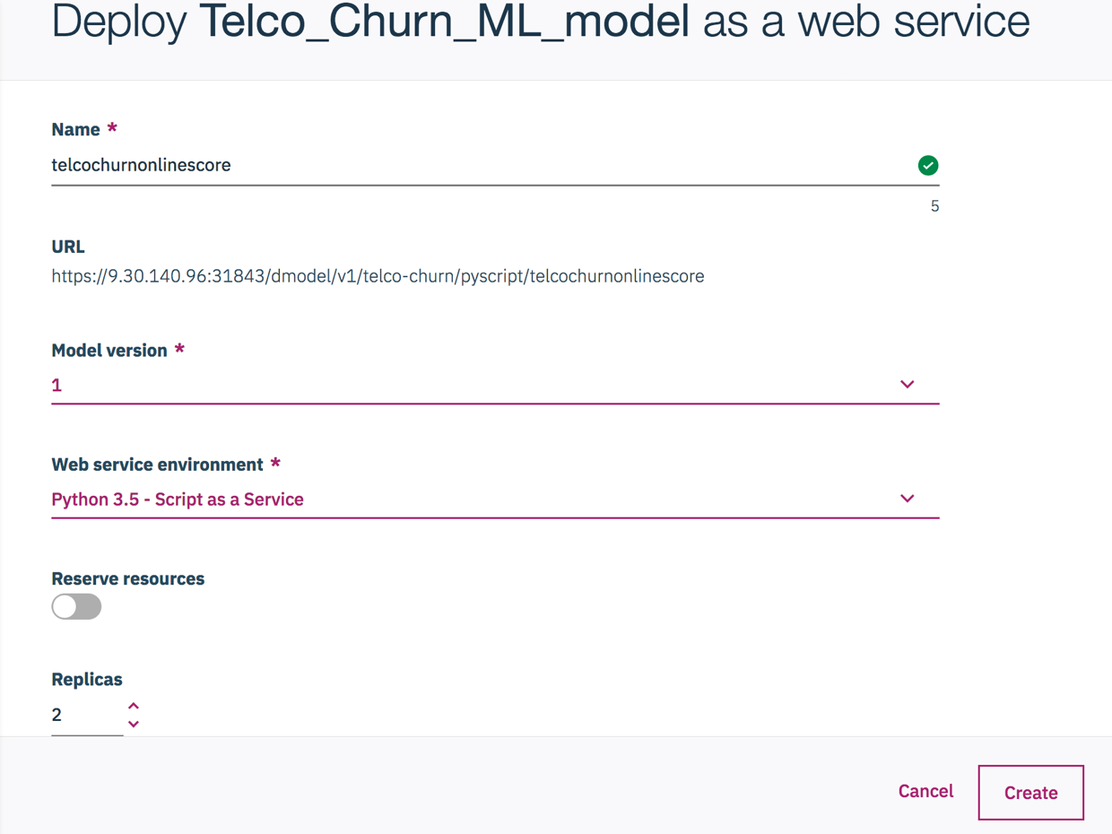

**Note**: At this time, the online deployment is created. You could also find the REST API and deployment token under ‘API’ tab. Simply click, the token is copied to your clipboard.

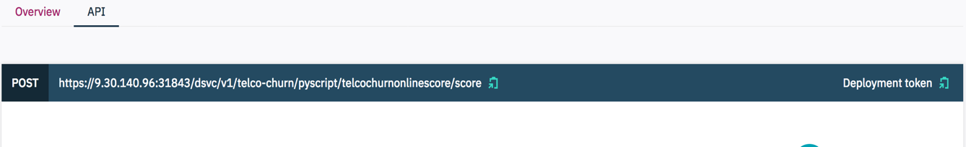

The deployment is not yet active so we need to launch and enable it before it can be used. We will do this later in the exercise below.

**Now we will Create an batch deployment for Telco_Churn_ML_model**

1. Navigate back to the‘**Assets’** tab. Select ‘**TelcoChurnMLBscore.py’** which is the batch scoring script we created in the development enviornment.
2. Add a job by clicking the ‘+**job’** botton on the top right.
3. Fill in the required information:
   * Name: **telcochurnbatchscore**
   * Type: **Batch scoring**.
   * Worker: **Jupyter with Python3.5**
   * Leave everything else as default
   * Click ‘**Create**’

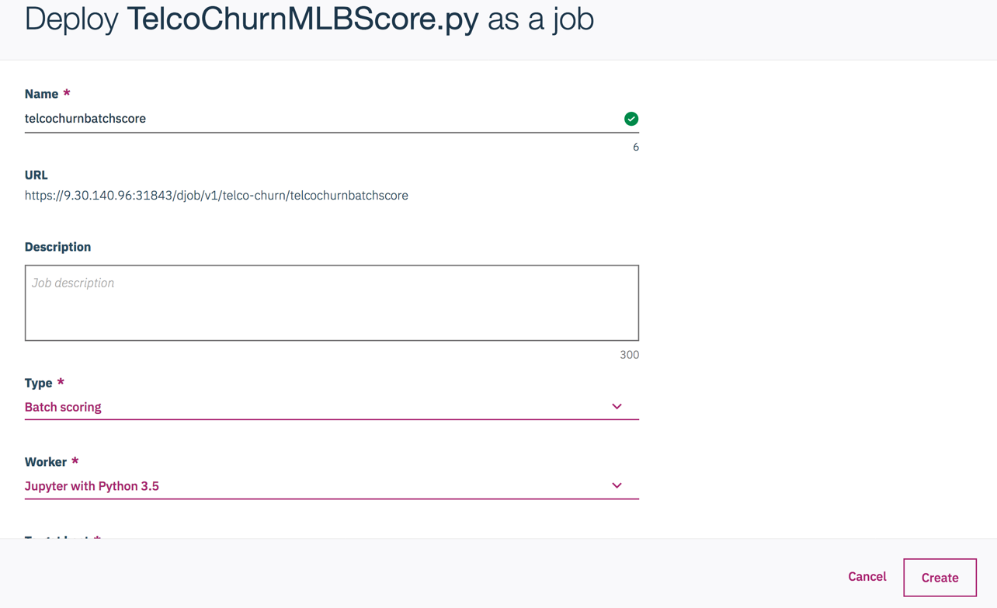

Note: As was the case above with online deplyment, the batch scoring job is not yet active. We need to launch it before it can be used.

**Launching and Enabling the Online and Batch Deployments**

1. Navigate back to the ‘**Assets**; view and select the ‘**Deployments’** tab, There are two jobs that just created. However, you will find that they are disabled for now.

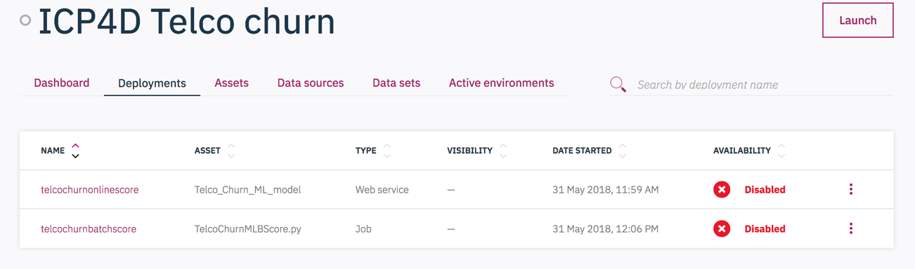

1. Click ‘**Launch’** on the top right to activate those deployments. This may take few minutes. You will see that the onlinescore job is still disabled. Because there are extra step to enable the online score: Go to right icon epsilon icon and click on **’Enable’**. This may takes a little longer. Wait until it changes to ‘enabled’.

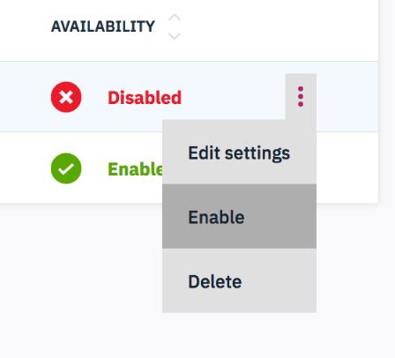

**Test the online deployment created in the API interface.**

1. From the ‘Deployment’ view click the oneline deployment then select the **‘API’** tab.
2. On the left hand side there are some inputs with ‘INSERT_VALUE’. Simply change it into a value that makes sense. For example, ‘dropped’ as 0 and ‘International’ as 0.

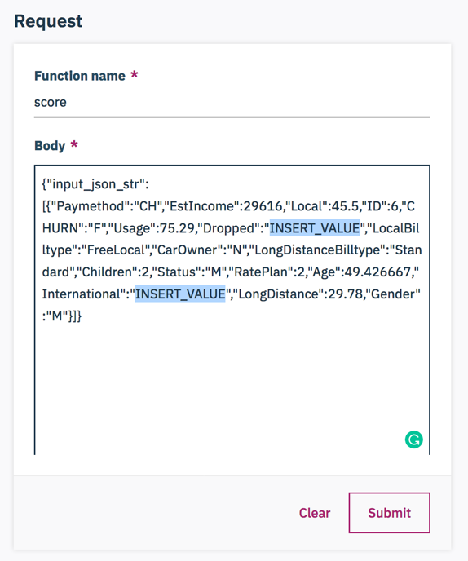 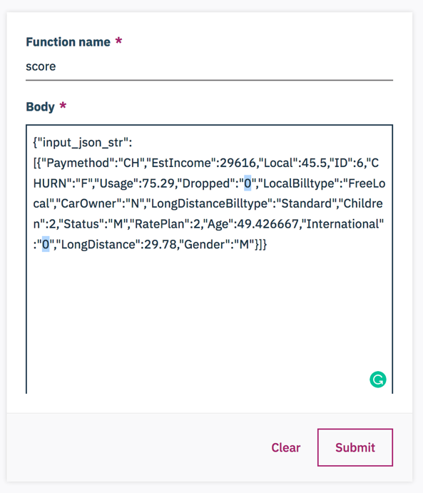

1. Click ‘**Submit’**. The result is shown on right with inputs and several prediction results.

**Note: Here is the end of instructions**

**Additional notice:**

i.Once you made some change to the project and deployment, just update the MMD inviornment and new version of assets are ready. 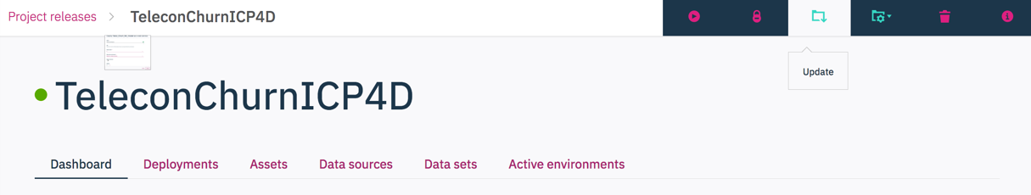

ii. Steps for deployment of evaluation is actually the same idea as batch score. You could explore it to see that’s different.

iii.The Dashboard show all of the deployment results. Including the performance of each evaluation.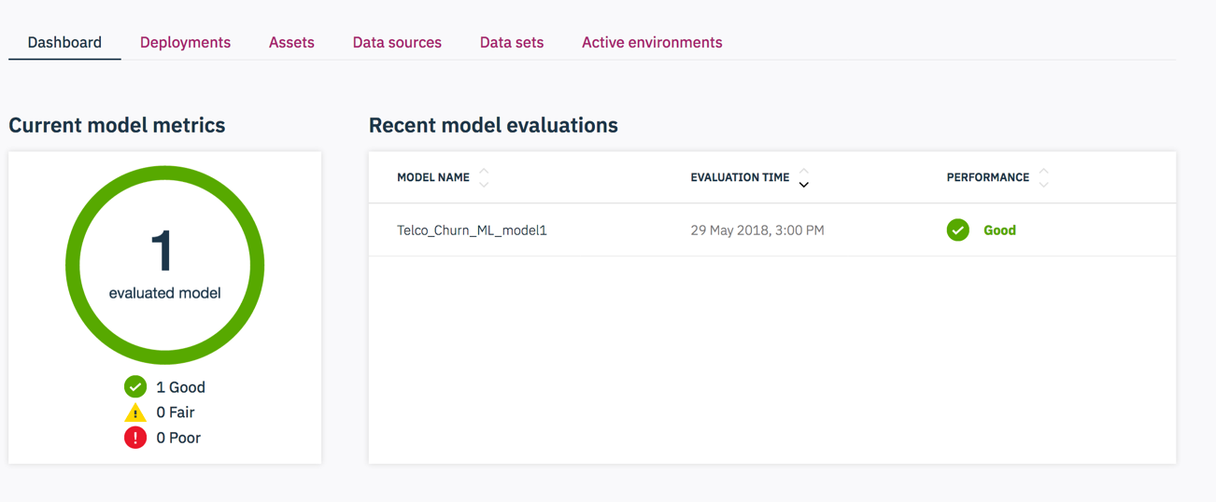

In this workshop of MMD enviornment, you’ve learned how to create a online and batch score, to enable those job and test those deployments.